**Instructions**

* Save your file as surnameforename.html.
* Use embedded style sheets.
* Once you have completed the exam, email your file to [anne.obrien@staff.ittralee.ie](mailto:anne.obrien@staff.ittralee.ie)
* Do not leave until I have received your exam.
* Please keep a copy of the exam until you get your results back.

**Screen Capture**

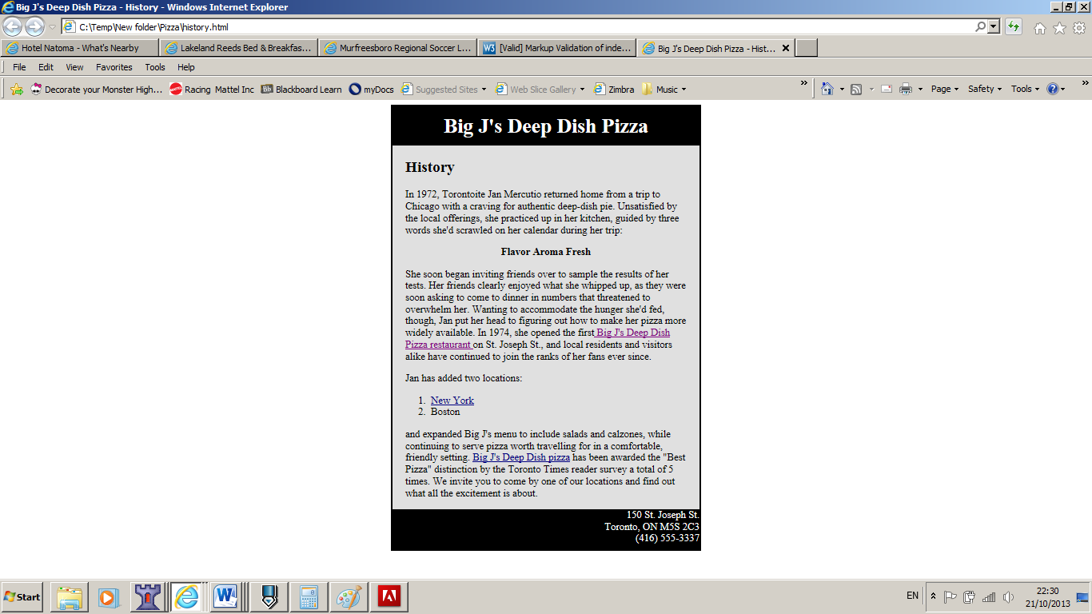

**Links**

Big J's Deep Dish pizza should link to a mail: bigj@yahoo.com

Big J's Deep Dish Pizza restaurant should link to:

<http://www.bjsrestaurants.com/menus/deep-dish-pizza>

New York: Based on the chart below and presuming you are in index.html, what would be the relative link to NewYork.html

**Text**

Big J's Deep Dish Pizza

History

In 1972, Torontoite Jan Mercutio returned home from a trip to Chicago with a craving for authentic deep-dish pie. Unsatisfied by the local offerings, she practiced up in her kitchen, guided by three words she'd scrawled on her calendar during her trip:

Flavor Aroma Fresh

She soon began inviting friends over to sample the results of her tests. Her friends clearly enjoyed what she whipped up, as they were soon asking to come to dinner in numbers that threatened to overwhelm her. Wanting to accommodate the hunger she'd fed, though, Jan put her head to figuring out how to make her pizza more widely available. In 1974, she opened the first Big J's Deep Dish Pizza restaurant on St. Joseph St., and local residents and visitors alike have continued to join the ranks of her fans ever since.

Jan has added two locations:

1. New York
2. Boston

and expanded Big J's menu to include salads and calzones, while continuing to serve pizza worth travelling for in a comfortable, friendly setting. Big J's Deep Dish pizza has been awarded the "Best Pizza" distinction by the Toronto Times reader survey a total of 5 times. We invite you to come by one of our locations and find out what all the excitement is about.

150 St. Joseph St.  
Toronto, ON M5S 2C3  
(416) 555-3337

**Settings**

The width of the box is: 480px

Background colours used :#e0e0e0